Week 9 - S9 - Advanced OOP - Object Class Methods, Inner Classes - Practice Problem

**Name:**Ramesh Harisabapathi Chettiar

**Date of Submission:**09/10/25

**QNO1🡪**

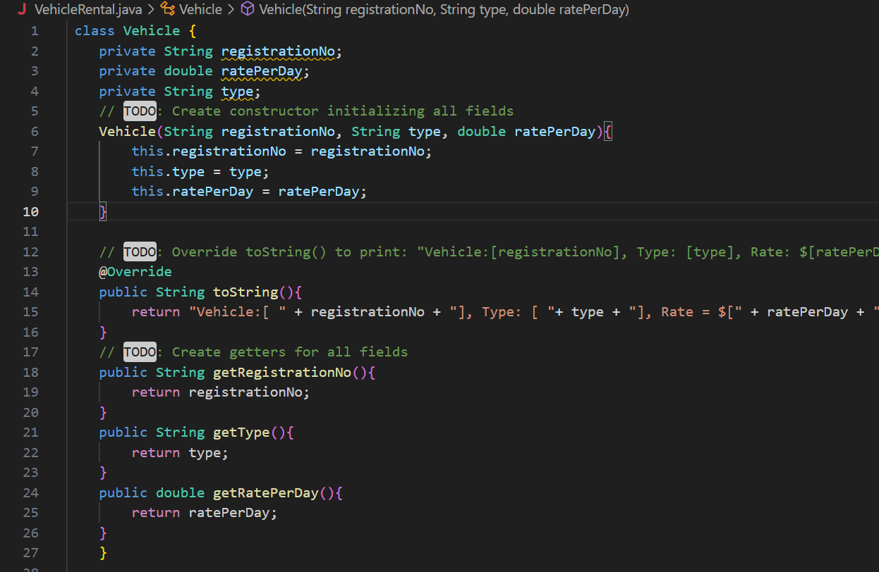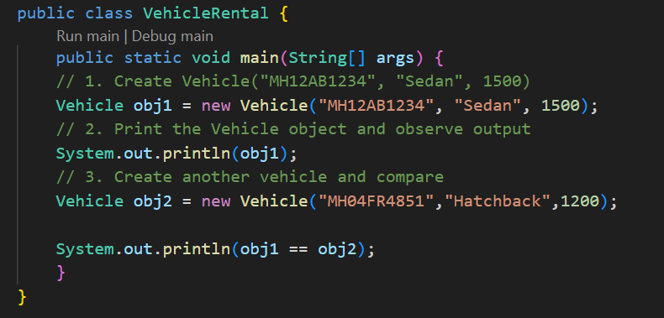

**OUTPUT🡪**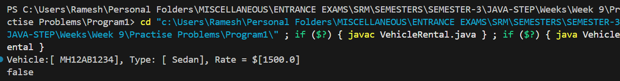

**QNO2🡪**

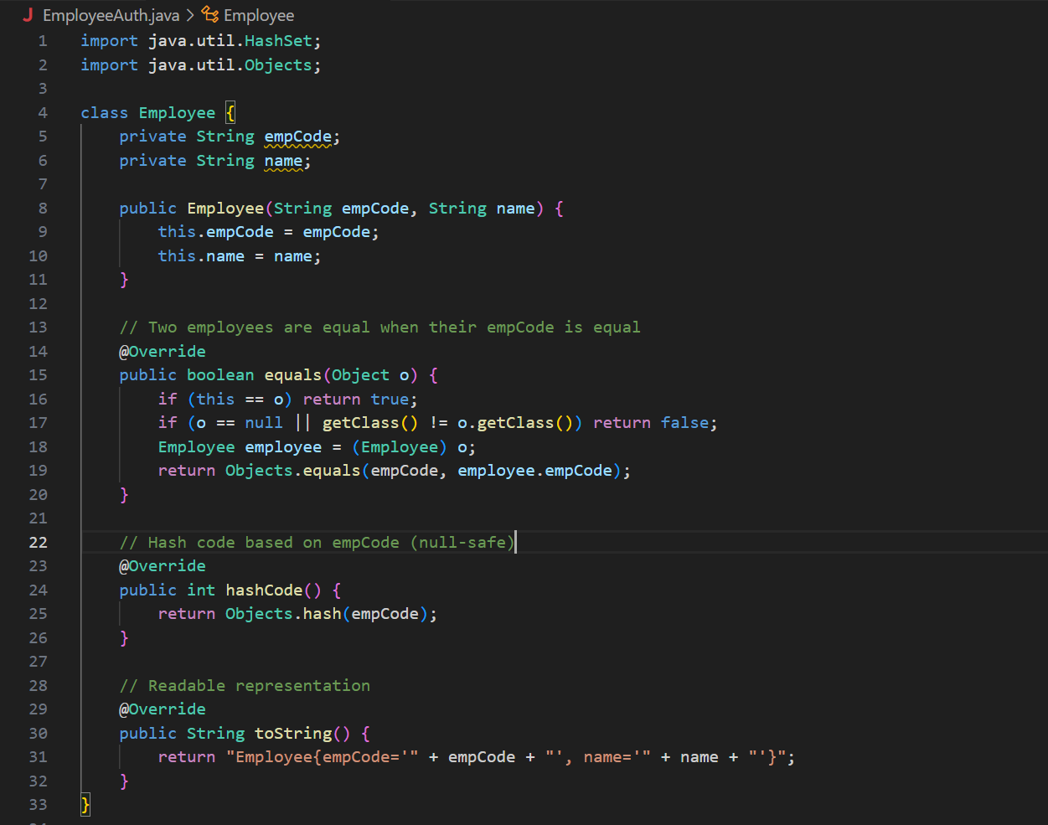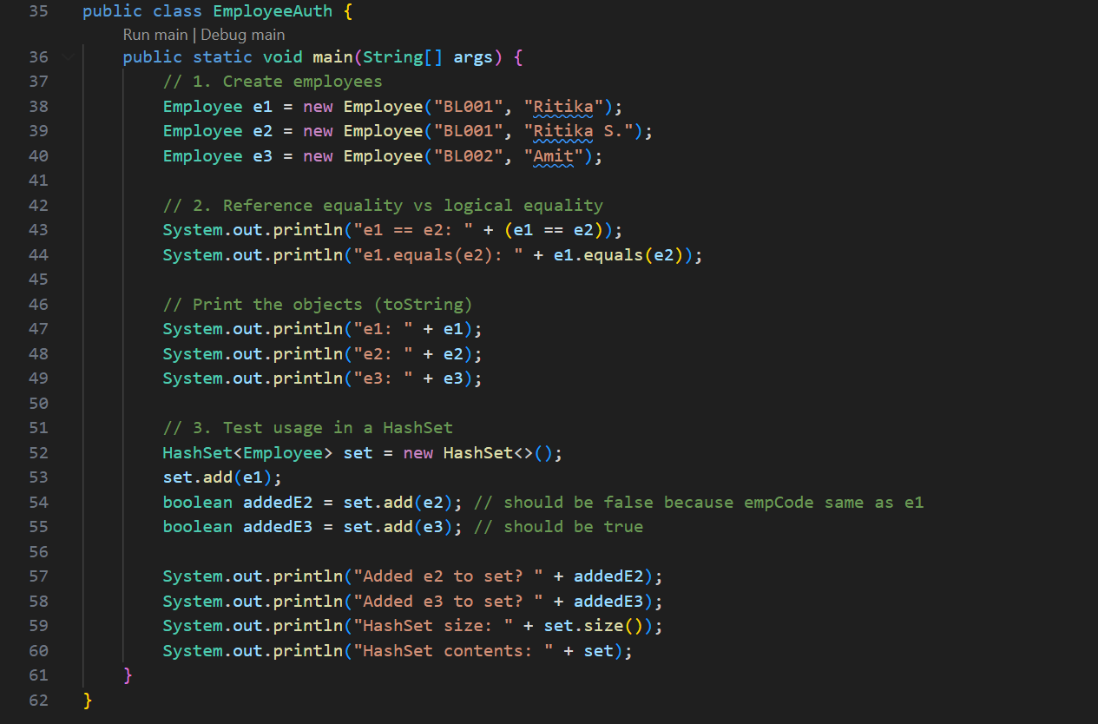

**OUTPUT🡪**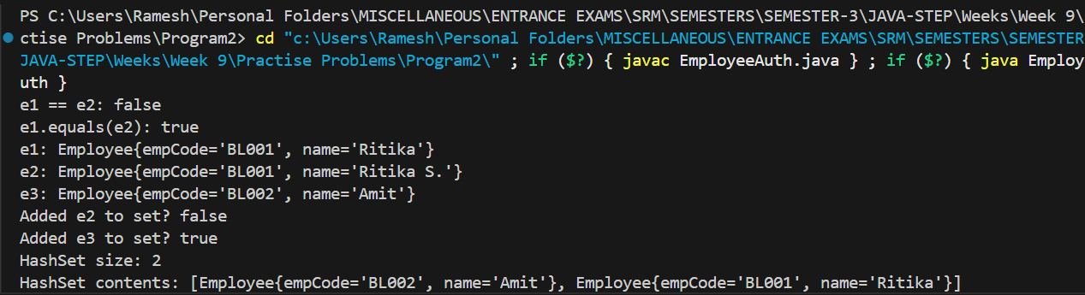

**QNO3🡪**

